# Part 3: QUESTION 4

**(a-1) Draw histograms (by hand) for both Age and Strength**

Computation Tables (Grouping)

|  |  |
| --- | --- |
|  |  |

Histograms

|  |  |
| --- | --- |
|  |  |

**(a-2) Comment on the shape of each distribution.**

Both distributions can be described as right skewed (with more data to the left)

**(b-1) Apply a natural log transformation**

Computation Tables (Applying Natural Logarithms, ln)



**(b-1) Re-draw histograms for the transformed variables**

Computation Tables (Grouping)

|  |  |
| --- | --- |
|  |  |

Histograms

|  |  |
| --- | --- |
|  |  |

**(c) Compute the regression coefficients β0 and β1 for the log-log model using the least squares method**

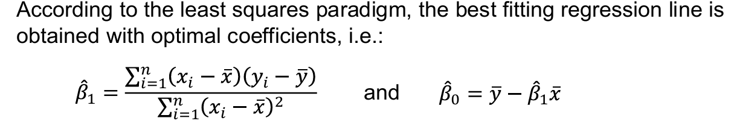

For *β*1:



For *β*0:

From



**(d) Determine the R2 value and interpret its meaning**

The formula below is used:



**(e) Compute the p-value for *β*1 and explain whether Age significantly affects Strength.**

Testing the Null Hypothesis



The p-value for ***β*1 = 0.005**. We reject the null hypothesis at the 5% significance level. This means that age has a statistically significant effect on the bending strength of alien beams, and we can be fairly confident (with 95% confidence) that the relationship isn’t due to chance.

**(f-1) Compute the residuals for the transformed model. Manually plot the residuals against the fitted values.**

Computation of the residuals



**(f-2) Manually plot the residuals against the fitted values.**

# Validate your hand calculations in R.

**------** (Code and Output shown in the following section) ----